# S3 File Upload with Presigned URL and Notifications

## Overview

This project demonstrates a secure way to allow users to upload files to an AWS S3 bucket using time-limited (presigned) URLs. It also ensures that every file upload triggers a notification via SNS (Simple Notification Service).

Key points:

* S3 bucket remains private — no public access.
* Presigned URLs allow uploads for a limited time, without exposing AWS credentials.
* SNS notifications alert users whenever a new object is uploaded.

## Steps

### 1. Create an S3 Bucket

1. Open AWS Console → S3 → Create bucket.
2. Enter a unique bucket name (e.g., mys3bkt-09-25) and choose your region (e.g., ap-south-1).
3. Keep Block all public access enabled.
4. Create the bucket.  
   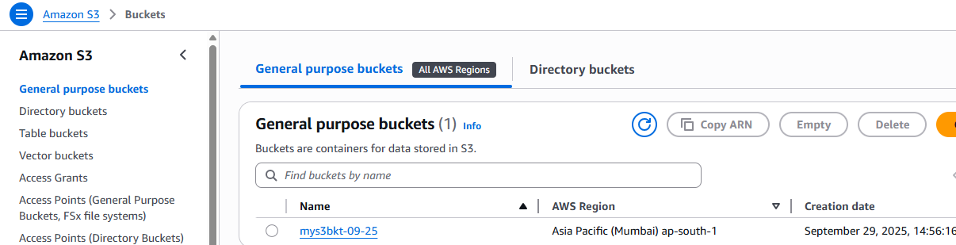

### 2. Create SNS Topic

1. Open AWS Console → SNS → Topics → Create topic.
2. Choose Standard, name it (e.g., S3Uploads).  
   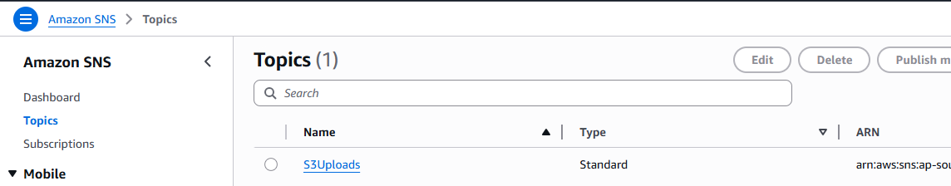
3. Subscribe your email to the topic and confirm the subscription.

### 3. Configure S3 Event Notifications

1. Open the S3 bucket → Properties → Event notifications → Create event notification.
2. Name: upload-events
3. Event types: PUT (ObjectCreated)
4. Destination: select the SNS topic created above.  
   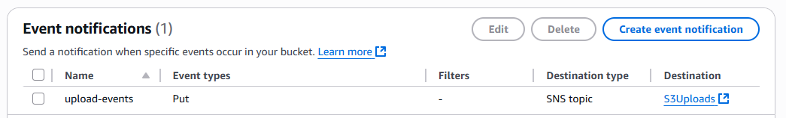
5. Save the notification. Now, every upload triggers an SNS email alert.

### 4. Uploading Files

1. Go to S3 bucket → Upload.
2. Select a file → upload.I’ve uploaded Test-File-01.txt for testing.  
   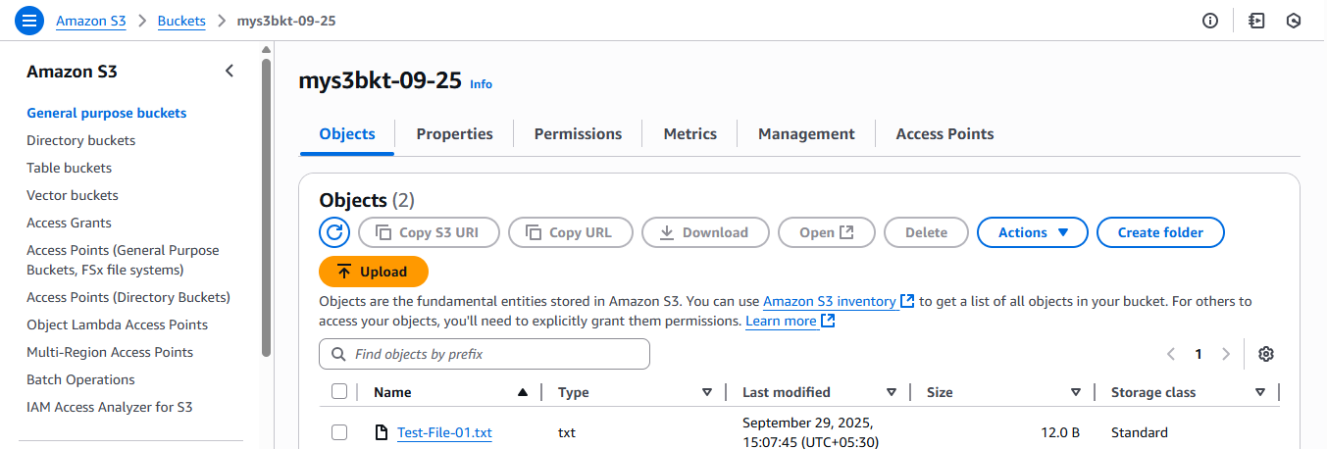
3. The file appears in the bucket, and an SNS notification is sent.  
   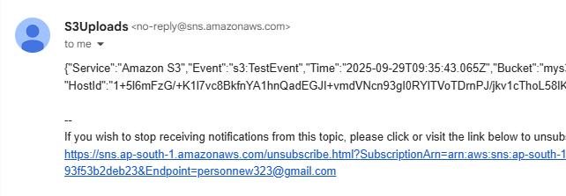
4. Select your file → click Actions → Share with a presigned URL.  
   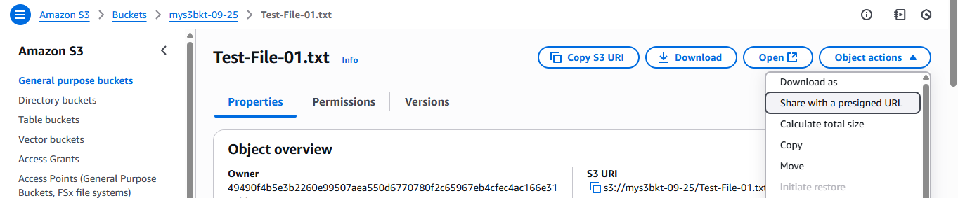
5. Choose expiry time (e.g., 1 minute).  
   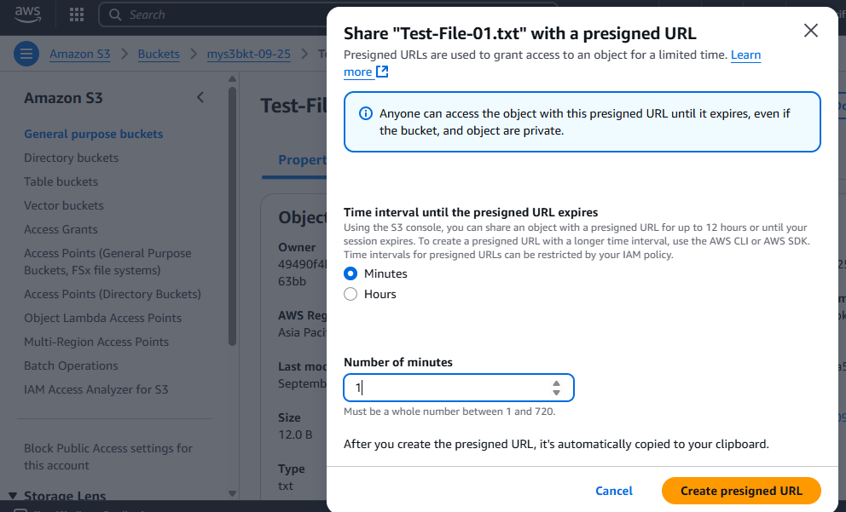
6. Copy the link and open it in your browser.I can now see the contents of the file that i had uploaded.

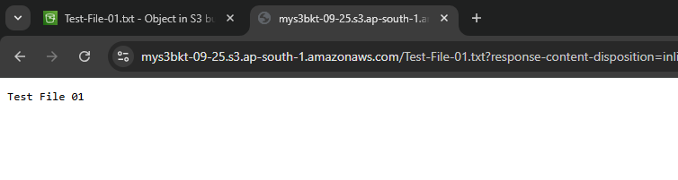  
The results after 1 min ( expiry time ) -   
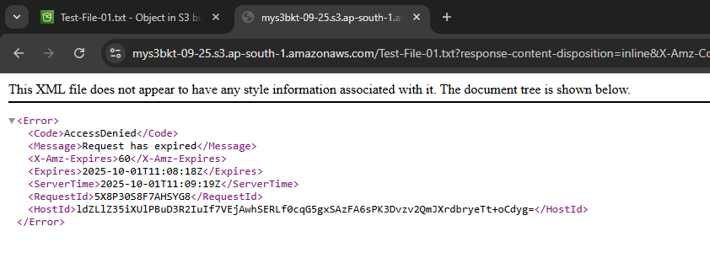

## Conclusion

This solution provides secure, temporary access to S3 for uploads without exposing credentials and notifications via SNS ensure monitoring of every upload event.